
February 2019

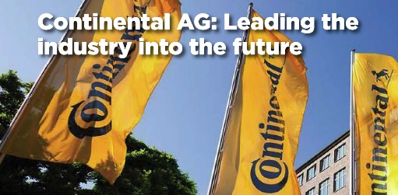
Cover Story – Hose & Coupling World
Check out the cover story in the February issue of Hose & Coupling World Magazine. This global publication features interviews with Karina Robinson, N.A. Market Director, Industrial Hose, and Jarek Zakrzewski, Digital Solutions Manager, where they discuss IFS’s PVC investment & our CrimpIQ technology. Click here to download the complete article.

Versabraid™ Redwing Fuel Oil Delivery Series Hoses
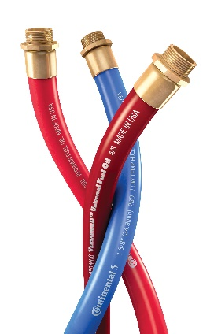
For years, our Redwing Fuel Oil hose had stood alone in the marketplace thanks to its unmatched quality and superior performance.
Despite our leading market position, we still had necessary improvements to make and we are happy to announce Redwing Fuel Oil is now better than ever and market ready! Not only has the product been enhanced, but it is backed by a brand-new performance guarantee!
For full details, along with information on our new Redwing Versabraid, please see our new Redwing Fuel Oil Delivery Series brochure!
Click here to download the new Versabraid Redwing Brochure

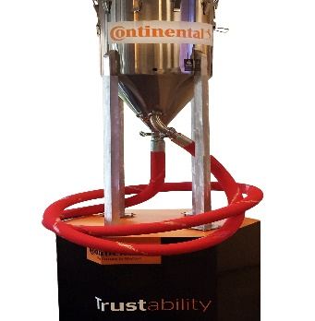
PurpleSnake to appear at the Craft Brew Conference
Did you know that the PurpleSnake hose is speced in at major breweries acress the globe due to that it is absolutely neutral to odor & taste and for its great flexibility? Stop by and see our exhibit at the Craft Brewers Conference April 8 – 11, 2019 in Denver, CO.
We will showcase the PurpleSnake, Extremeflex Beverage, and other brewery hoses & accesssories. Learn more about the PurpleSnake in this short educational video and our one-page overview flyer.

BT- Family of 1-pc, no-skive Fittings for HR4 (SAE 100R4) Hydraulic Hose are In Stock
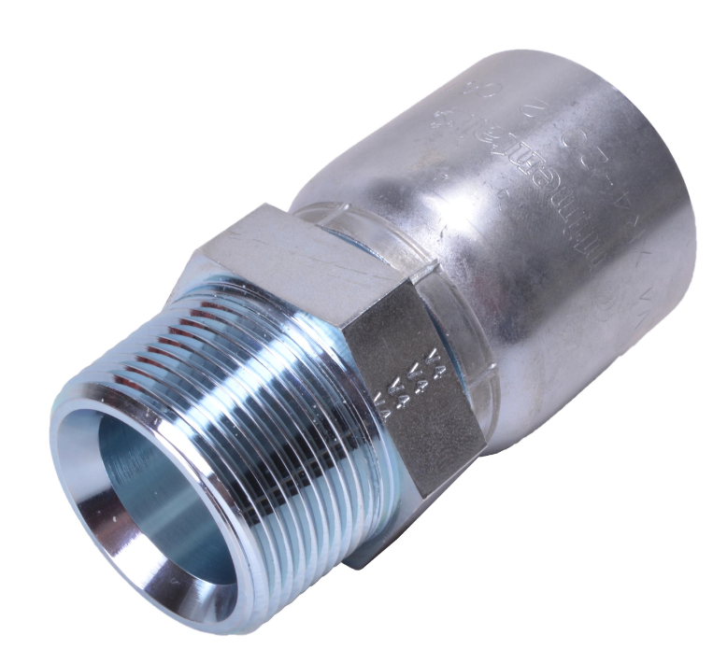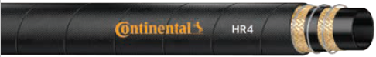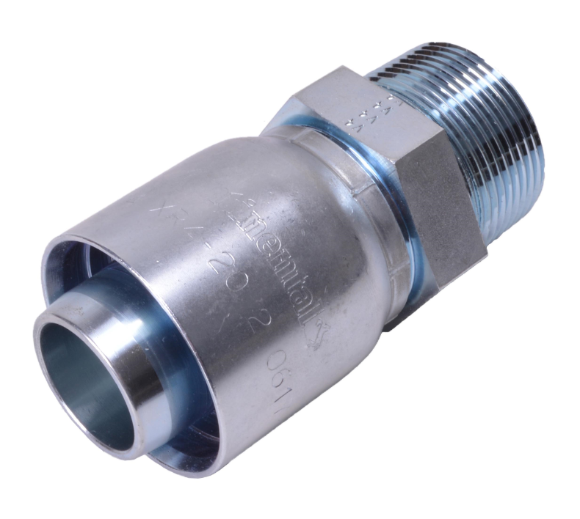
The BT- family of fittings offer a 1-piece solution for HR4 hose. Now available in stock for 3/4” to 2” ID hose, these fittings are an alternative to our existing UC-, 2-piece fittings, for those who prefer the simplicity of the 1-pc solution. The BT-‘s are currently available with JIC 37º; NPTF, ORFS, and Code 61 end connections. Consult your 2018/2019 Hydraulics Catalog for information on the specific SKUs. Crimp specifications are available in V43.1 of the Hydraulic Crimp Specification. The current UC- family is still carried in our line and remains an option as a fitting solution.

STAR Training Announcement
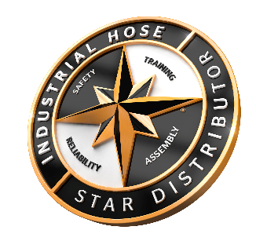
Registration is now open for the 2019 Industrial Hose STAR Training Class. This popular Industrial Hose training will be held at the Le St. Martin Hotel in Bromont, QC Canada May 14 – 16, 2019. This class is ideal for seasoned sales professionals looking to improve their knowledge base on hoses and improve their selling skills. See announcement for class details and be sure to register your spot today.


Are you registered for the Conti Fluid Solutions tool?

ContiFluid Solutions is the “all thing industrial & Hydraulic hose” designed specifically for you, our Distributor Sales, Customer Service, and Marketing Partners. Loaded with new product information, training material, #didyouknow tips, videos, Social Media Content (ready for you to post), and much more.
To login/register for this tool link to www.contifluidsolutions.com. If you’re a new user click the “Register” button.

Take the IFS February Quiz
What is our best cover for abrasion resistance for Continental Hydraulic hoses?
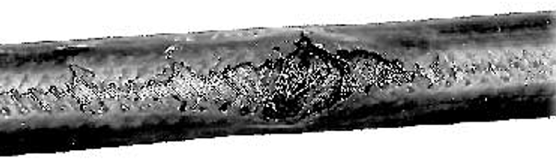
- “S” Series (SR2SN)
- “ARC” Armorcoat (ACP3)
- “X” Extended Life (XR16SC)
- “D” Desert (DR16SC)

#didyouknow (Tip 75)

Did you know that we have a best practices tip sheet for our Fuel Oil Delivery Hose? A great 1-piece flyer to discuss with your customers this winter to ensure that they are being safe and includes a chart to help you select the best fuel delivery hose to meet your application needs. Click here to download and check out www.contifluidsolutions.com for our complete list of #didyouknow tips. As a reminder, a new tip is added each week.

Upcoming IFS Training & Trade Show Schedule 2019
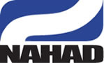 | NAHAD 35th Annual Convention  Apr 5 – 10, 2019  Bellagio Hotel  Las Vegas, NV
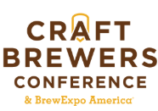 | Craft Brewers Conference & Expo  Apr 8 – 11  Colorado Convention Center,  Denver, CO
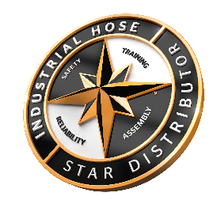 | STAR Training  May 14 – 16, 2019  Le St. Martin Hotel  Bromont, QC
 | Global Petroleum Show  June 11 – 13, 2019  Stampede Park, Calgary, AB
Be sure to visit Industrial Fluid Solution Hose Marketing and your local Continental Hose Sales Associates at these upcoming trade & training events.
Mark your calendar for the Annual NAHAD Conference. Stop by our hospitality event on Sunday April 7th to meet the IFS Marketing & Management team.
See our Beverge Hose line up including the Purple Snake & Extremeflex Beverage hoses at the annual Craft Brewers Conference in Denver, CO April 8 – 11, 2019.
The 2019 Industrial Hose STAR Training Class is scheduled, click the STAR Logo to download registration forms. See registration announcement for class details.
Join us at the Global Petroleum Show in Calgary this June and see our Petroleum Transfer hoses.
To learn more about these events and to register for each, click the show icons.

February Quiz Results
The correct answer is B. “ARC” Armorcoat
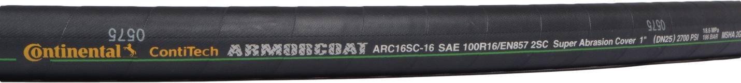
The number one cause for hose failure is abrasion. Our line of super abrasion resistance hoses, “ARC,” Armorcoat™ are manufactured using a UHMWPE (Ultra High Molecular Weight Polyethylene) jacket that protects against long-term abrasion in the most adverse applications. Install with confidence and know you’ve got one tough hose that will stand the test of time!

